Principal Survey Results
2021-22

The purpose of the Principal survey was to glean from our area principals their perspective on how effective we have been at preparing our students in the field. In so doing these principals were asked to rate (on a 4-point scale) the overall performance of our Hope graduates on seven professional abilities (ethical educators (dispositions), skilled communicators, engaged professionals, curriculum developers, effective instructors, decision-makers, and reflective practitioners) evidenced in four domains and one disposition (teaching dispositions, planning, classroom environment, instructional practice, and professional responsibilities. These constructs are informed by Danielson’s framework for teachers.

Big Picture Overview

Professional Ability and Danielson Framework Four Domains
Descriptive Statistics
Professional Abilities (4 pt Likert Scale) |  |  |  |  |  |  | Teacher Disposition + Four Domain Sub Scores
 | Items  (N) | 2022  Mean (SD) | 2020  Mean (SD) | 2022 % | 2020  % |  |  | Items (N) | 2022  Mean SD) | 2020  Mean (SD) | 2019  % |  | 2020  %
Ethical  Educator | 9Q* | 3.69 (.23) | 3.75 (.38) | 92.93 | 92.25 |  | Teacher Disposition | 9Q* | 3.69 (.29) | 3.28 (.29) | 92.25 |  | 87.17
Engaged Professional | 9Q* | 3.72 (.28) | 3.59 (.45) | 93.00 | 89.64 |  | D1: Planning | 10Q * | 3.57 (.36) | 3.45 (.38) | 89.25 | 86.36
Effective  Instructor | 6Q* | 364 (.28) | 3.65 (.38) | 91.00 | 90.91 |  | D2: Classroom Environment | 7Q* | 3.71 (.26) | 3.62 (.52) | 92.75 | 90.58
Reflective Practitioner | 6Q | 3.60 (.27) | 3.52 (.45) | 90.00 | 87.88 |  | D3: Instructional  Practice | 11Q* | 3.60 (.28) | 3.58 (.36) | 90.00 | 89.55
Curriculum Developer | 6Q | 3.68 (.37) | 3.53 (.45) | 92.00 | 88.26 |  | D4: Professional Responsibilities | 9Q * | 3.80 (.24) | 3.67 (.43) | 95.00 | 89.89
Decision  Maker | 2Q | 3.59 (.29) | 3.55 (.47) | 89.75 | 88.64 |  | *Note: Number of questions shifted as we removed duplicate items and better aligned the constructs. Only one new item (a culturally responsive question) was added. 96% of the survey remained the same.  Q = questions SD = Standard Deviation N = sample size
Skilled Communicator | 5Q* | 3.85 (.22) | 3.58 (.51) | 96.25 | 89.55
Professional Ability Mastery |  | 3.68 (.27) | 3.60 (.08) | 92.27 | 89.89 |  | Domain and Teacher Disposition Mastery |  | 3.67 (.29) | 3.50 (.38) | 91.67 |  | 89.10

Overall, the principals rated our second-year graduates as mastering the Professional Abilities; scores ranged from 3.59 (90%) to 3.85 (96%) out of a possible 4-point scale.
Overall, the principals rated our second-year graduates as being effective in the professional domains and dispositions. The domain/disposition scores ranged from 3.57 (89%%) to 3.80 (95%) out of a possible 4-point scale.

Thus, these Principal Survey scores indicate that our graduates demonstrate teacher effectiveness to the satisfaction of their employers (the principals themselves).

Professional Abilities

Professional Abilities - ANOVA : F(6,693)=9.87, p=0
Professional  Ability | Number of  Questions | Bootstrapped  N | Score  (Out of 4) | Std Error | Percent
SC-Skilled Communicator | 5Q | 100 | 3.85 | 0.22 | 96%
EP-Engaged Professional | 9Q | 100 | 3.72 | 0.28 | 93%
EE-Ethical Educator | 9Q | 100 | 3.69 | 0.23 | 92%
CD-Curriculum Developer | 6Q | 100 | 3.68 | 0.37 | 92%
EI-Effective Instructor | 6Q | 100 | 3.64 | 0.28 | 91%
RP-Reflective Practitioner | 6Q | 100 | 3.60 | 0.27 | 90%
DM-Decision Maker | 2Q | 100 | 3.59 | 0.29 | 90%
α=.05

As reflective practitioners we are always looking for ways to improve our program and our graduates performance in the field. So, while our students have excelled, when digging deeper into each of the Domain skills, we found areas where our graduates could do even better:

Professional Abilities.

The Principals felt that our graduates performed extremely well in communication (skilled at communicating procedures, expectations, and instructional practices – 96%); that score was significantly higher than any other professional ability construct. Our graduates ranked second in how well they engaged in professional endeavors (e.g., complying with district policies, built professional relationships, and participated in school and district activities).

The principals scored our graduates lowest (90% respectively) in two areas reflective practitioner (e.g., using technology wisely, addressing student behaviors, and develop professional, evidence-based goals collaboratively); and making decisions (e.g., choosing appropriate materials and making the classroom safe). These areas were significantly lower than our top two (p < .05)
Four Overarching Domains & Disposition

DOMAINS & Disposition F(4,495)=10.25, p = 0
Professional Dispositions and Domains | Number of  Questions | Bootstrapped  N | Score  (Out of 4) | Std Error | Percent
Professional Responsibilities | 9Q | 100 | 3.80 | 0.24 | 95%
Classroom Environment | 7Q | 100 | 3.71 | 0.26 | 93%
Teacher Dispositions | 9Q | 100 | 3.69 | 0.29 | 92%
Instructional Practice | 11Q | 100 | 3.60 | 0.28 | 90%
Planning | 10Q | 100 | 3.57 | 0.36 | 89%
α=.05

The principals rated our students highly (95% and 93%, respectively) in our graduates’ carrying out the responsibilities of the profession and managing the classroom environment. We ranked lowest in planning and instructional practice.

Delving Deeper

Because the seven professional abilities are subsumed within the domains and dispositions, we will delve deeper into each category paying close attention to any scores lower than 85% (3.4 on a 4-point scale). These areas will be our target for the upcoming year as we continue to improve our education program. We will celebrate any scores above a 95% (3.8 on a 4-point scale).

Domain: Professional Responsibility

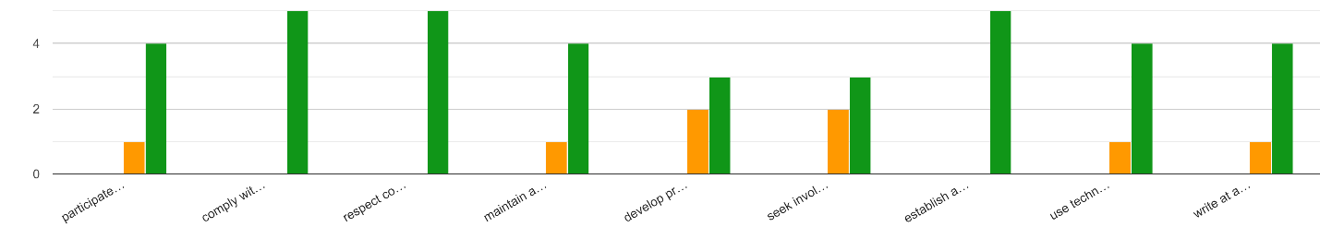
participate in school and district activities
comply with district/ school policies
respect confiden-tiality of the classroom
maintain accurate records
develop professional evidenced-based goals collabora-tively
seek involve-ment in a culture of profess-sional inquiry
establish and maintain profess-sional relation-ships
use technology to commun-icate with students and parents
write at a professional level

3.46
3.73 3.73 3.73 3.64

3.45 3.64 3.55
3.45

Professional responsibility scores ranged from 3.45 (85%) to 3.73 (93%). While no scores were under our 85% (3.4) threshold, we will continue to work on our lowest scores star’d above: developing professional evidence-based goals collaboratively and seeking involvement in a culture of professional inquiry.

Domain: Classroom Environment

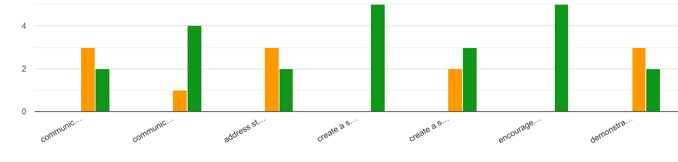
Create a safe physical environment
Demon-strate cultural respon-siveness to all students
Encourage positive student-to-student interactions
Commu-nicate high expectations for students’ learning
Address student behavior
Create a safe learning environment
Communicate clear expec-tations for student behaviors
3.55
3.91
3.36
3.91
3.55
3.55

3.55

Classroom Environment scores ranged from 3.36 (84%) to 3.91 (98%). We will work on addressing student behavior with our teacher candidates, even as we celebrate the fact that our students encourage positive student-to-student interactions.
Teacher Dispositions

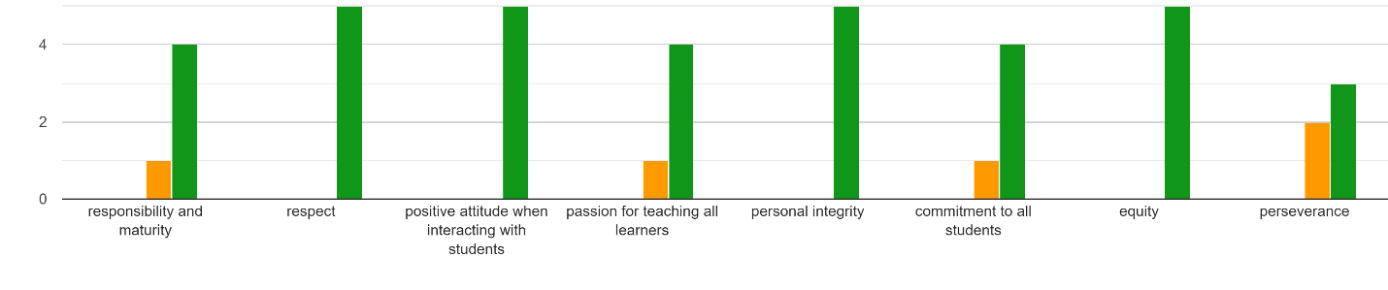
Responsi-bility and maturity
Positive attitude when interacting with students
Passion for teaching all learners
Personal integrity
Commitment to all students
equity
Respect
Perse-verance
3.75
3.88
3.88
3.75
3.63
3.75
3.50
3.50

Teacher Disposition scores ranged from 3.50 (88%) to 3.88 (97%). While no scores were under our 85% (3.4) threshold, we will continue to work on our lowest scores –perseverance. We will celebrate the fact that our students keep a positive attitude when interacting with students.

Domain: Instructional Practice

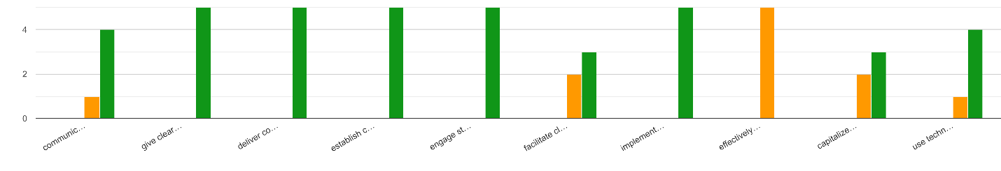

Effective use of formative assess-ment to gauge student progress in meeting appro-priate content standards
Imple-ment suitable pacing
Use tech-nology to enhance instruct-tion
Capitalize on teachable moments and demon-strate respon-sivenss to students with appro-priate feedback
Facilitate classroom discussions by encour-aging students to explain their thinking
Engage students in their subject matter
Establish clear, measure-able objectives
Deliver content accurately
Give clear directions
Commu-nicate procedures effectively

3.64
3.55
3.64
3.55
3.55
3.73
3.64

3.55

Instructional Practice scores ranged from 3.27 (82%) to 3.74 (94%).
3.27
We will work on addressing the effective use of formative assessments to
3.74
gauge student progress in meeting appropriate content standards with our
teacher candidates. even as we celebrate the fact that our students encourage
positive student-to-student interactions. We will also look at facilitating classroom discussions
through having students explain their thinking. These aligned with our High Leverage Practice goals.

Domain: Planning

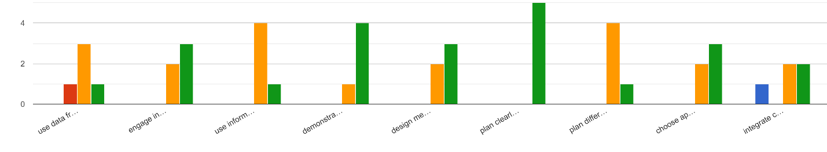
Use data from school-wide and classroom assessment to plan instruction
Use infor-mative & summative results to inform instruction
Demon-strate knowledge of both subject area & curriculum embedded / evidence-based research
design mean- ingful learning exper-iences
plan clearly structured lessons
plan differ-entiated instruct-tion based on individual student differ-ences
Engage in meaningful reflection of lessons
choose appro-priate materials
3.36
3.55
3.40
3.64
3.73
3.55
3.50
3.45
integrate content across disciplines

3.18
3.55

Planning scores ranged from 3.18 (80%) to 3.73 (93%). This is our weakest domain. We have three areas targeted for improvement: Planning integrated content lessons across disciplines; Using data from school wide and classroom assessment to plan instruction; and using informative and summative assessment results to inform instruction.

Qualitative Responses
2022-2023

The final item on the survey gave the principles a chance to speak their minds regarding any pertinent information they wished to share. We received positive feedback on our program exemplified by the comment that “our Hope graduates stand out among our group of new teachers. I have hired 3 new teachers from Hope in the last 5 years and they are very well prepared. Thank you.” We also received thanks for allowing the principles to be a part of the evaluation process and for “allowing students into classrooms as much as possible while learning.” We were also wished a “good luck” as we reflect upon our progress thus far and make plans to make our program even better.

